14.
Controlled Release Medication

An ideal dosage regimen in the drug therapy of any disease is the one which immediately attains the desired therapeutic concentration of drug in plasma (or at the site of action) and maintains it constant for the entire duration of treatment. This is possible through administration of a drug delivery system in a particular dose and at a particular frequency. The term drug delivery covers a broad range of techniques used to get therapeutic agents into the human body. The frequency of administration or the dosing interval of any drug depends upon its half-life or mean residence time (MRT) and its therapeutic index. When a drug is delivered as a conventional dosage form such as a tablet, the dosing interval is much shorter than the half-life of the drug resulting in a number of limitations associated with such a conventional dosage form:
- Poor patient compliance; increased chances of missing the dose of a drug with short half-life for which frequent administration is necessary.
- A typical peak-valley plasma concentration-time profile is obtained which makes attainment of steady-state condition difficult (see Fig. 14.1).
- The unavoidable fluctuations in the drug concentration may lead to under-medication or over-medication as the Css values fall or rise beyond the therapeutic range.
- The fluctuating drug levels may lead to precipitation of adverse effects especially of a drug with small therapeutic index whenever overmedication occurs.
There are two ways to overcome such a situation –
- Development of new, better and safer drugs with long half-lives and large therapeutic indices, and
- Effective and safer use of existing drugs through concepts and techniques of controlled and targeted delivery systems.

The first approach has many disadvantages which therefore resulted in increased interest in the second approach. The second approach, owing to several technical advancements, has resulted in the development of drug delivery systems capable of controlling the rate of drug delivery, sustaining the duration of therapeutic action and/or targeting the delivery of drug to a particular tissue. An ideal drug delivery system should deliver the drug at a rate dictated by the needs of the body over a specified period of treatment. This idealized objective points to the two aspects most important to drug delivery –
- Spatial delivery of drug which relates to targeting a drug to a specific organ or tissue, and
- Temporal delivery of drug which refers to controlling the rate or specific time of drug delivery to the target tissue.
An appropriately designed controlled-release drug-delivery system (CRDDS) can improve the therapeutic efficacy and safety of a drug by precise temporal and spatial placement in the body, thereby reducing both the size and number of doses required (see Figure 14.1).

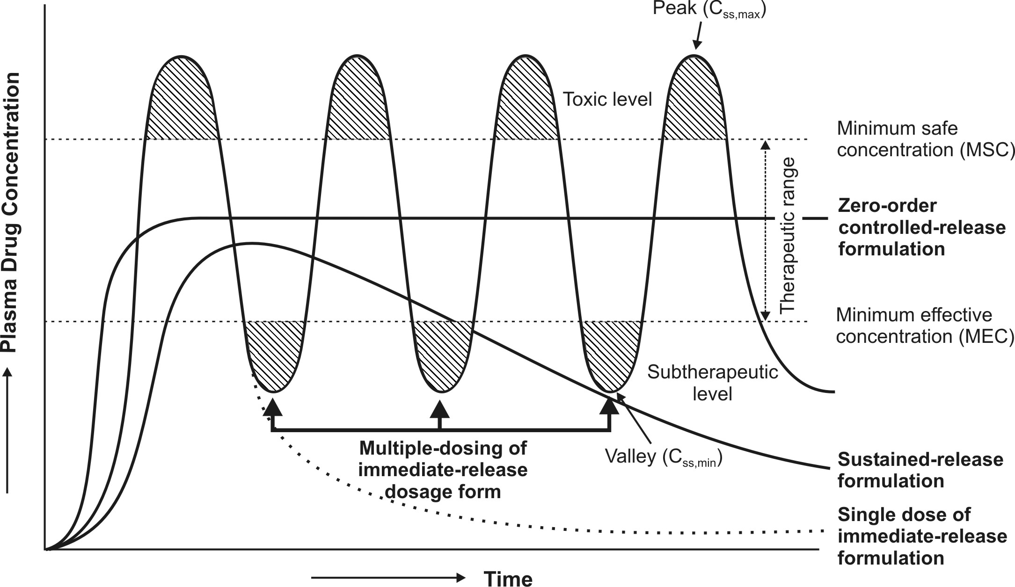
Fig. 14.1 A hypothetical plasma concentration-time profile from conventional multiple dosing and an ideal controlled delivery formulation
The several advantages of a controlled drug delivery system over a conventional dosage form are—
- Improved patient convenience and compliance due to less frequent drug administration.
- Reduction in fluctuation in steady-state levels (Fig. 14.1) and therefore –
- Better control of disease condition, and
- Reduced intensity of local or systemic side-effects.
- Increased safety margin of high potency drugs due to better control of plasma levels.
- Maximum utilization of drug enabling reduction in total amount of dose administered.
- Reduction in health care costs through –
- Improved therapy
- Shorter treatment period
- Lower frequency of dosing, and
- Reduction in personnel time to dispense, administer and monitor patients.
Disadvantages of controlled-release dosage forms include —
- Decreased systemic availability in comparison to immediate-release conventional dosage forms. This may be due to –
- Incomplete release
- Increased first-pass metabolism
- Increased instability
- Insufficient residence time for complete release
- Site-specific absorption
- pH-dependent solubility.
- Poor in vitro–in vivo correlation.
- Possibility of dose dumping due to food, physiologic or formulation variables or chewing or grinding of oral formulations by the patient and thus, increased risk of toxicity.
- Retrieval of drug is difficult in case of toxicity, poisoning or hypersensitivity reactions.
- Reduced potential for dosage adjustment of drugs normally administered in varying strengths.
- Higher cost of formulation.
FACTORS IN THE DESIGN OF
CONTROLLED-RELEASE DRUG DELIVERY SYSTEMS
The basic rationale of a controlled release drug delivery system is to optimise the biopharmaceutic, pharmacokinetic and pharmacodynamic properties of a drug in such a way that its utility is maximized through reduction in side effects and cure or control of condition in the shortest possible time by using smallest quantity of drug, administered by the most suitable route.
A. Biopharmaceutic Characteristics of a Drug in the Design of CRDDS
The performance of a drug presented as a controlled-release system depends upon its:
- Release from the formulation.
- Movement within the body during its passage to the site of action.
The former depends upon the fabrication of the formulation and the physicochemical properties of the drug while the latter element is dependent upon pharmacokinetics of drug. In comparison to conventional dosage form where the rate-limiting step in drug availability is usually absorption through the biomembrane, the rate-determining step in the availability of a drug from controlled delivery system is the rate of release of drug from the dosage form which is much smaller than the intrinsic absorption rate for the drug (Fig. 14.2).
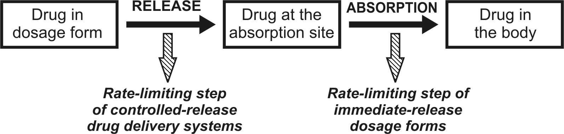
Fig. 14.2 Scheme representing the rate-limiting step in the design of controlled-release drug delivery system
The type of delivery system and the route of administration of the drug presented in controlled-release dosage form depend upon the physicochemical properties of the drug and its biopharmaceutic characteristics. The desired biopharmaceutic properties of a drug to be used in a controlled-release drug delivery system are discussed below.
1. Molecular Weight of the Drug: Lower the molecular weight, faster and more complete the absorption. For drugs absorbed by pore transport mechanism, the molecular size threshold is 150 Daltons for spherical compounds and 400 Daltons for linear compounds. However, more than 95% of drugs are absorbed by passive diffusion. Diffusivity, defined as the ability of a drug to diffuse through the membranes, is inversely related to molecular size. The upper limit of drug molecular size for passive diffusion is 600 Daltons. Drugs with large molecular size are poor candidates for oral controlled-release systems e.g. peptides and proteins.
2. Aqueous Solubility of the Drug: A drug with good aqueous solubility, especially if pH-independent, serves as a good candidate for controlled-release dosage forms e.g. pentoxifylline. The lower limit of solubility of a drug to be formulated as CRDDS is 0.1mg/ml. Drugs with pH-dependent aqueous solubility e.g. phenytoin, or drugs with solubility in non-aqueous solvents e.g. steroids, are suitable for parenteral (e.g. i.m depots) controlled-release dosage forms; the drug precipitates at the injection site and thus, its release is slowed down due to change in pH or contact with aqueous body fluids. Solubility of drug can limit the choice of mechanism to be employed in CRDDS, for example, diffusional systems are not suitable for poorly soluble drugs. Absorption of poorly soluble drugs is dissolution rate-limited which means that the controlled-release device does not control the absorption process; hence, they are poor candidates for such systems.
3. Apparent Partition Coefficient/Lipophilicity of the Drug: Greater the apparent partition coefficient of a drug, greater its lipophilicity and thus, greater is its rate and extent of absorption. Such drugs have increased tendency to cross even the more selective barriers like BBB. The apparent volume of distribution of such drugs also increases due to increased partitioning into the fatty tissues and since the blood flow rate to such tissues is always lower than that to an aqueous tissue like liver, they may exhibit characteristics of models having two or more compartments. The parameter is also important in determining the release rate of a drug from lipophilic matrix or device.
4. Drug pKa and Ionisation at Physiological pH: The pKa range for acidic drugs whose ionisation is pH-sensitive is 3.0 to 7.5 and that for basic drugs is 7.0 to 11.0. For optimum passive absorption, the drugs should be non-ionised at that site at least to an extent 0.1 to 5%. Drugs existing largely in ionised forms are poor candidates for controlled delivery e.g. hexamethonium.
5. Drug Permeability: The three major drug characteristics that determine the permeability of drugs for passive transport across intestinal epithelium are –
- Lipophilicity, expressed as log P.
- Polarity of drug which is measured by the number of H-bond acceptors and number of H-bond donors on the drug molecule.
- Molecular size.
The influence of each of these properties has been discussed above.
6. Drug Stability: Drugs unstable in GI environment cannot be administered as oral controlled-release formulation because of bioavailability problems e.g. nitroglycerine. A different route of administration should then be selected such as the transdermal route. Drugs unstable in gastric pH, e.g. propantheline can be designed for sustained delivery in intestine with limited or no delivery in stomach. On the other hand, a drug unstable in intestine, e.g. probanthine, can be formulated as gastroretentive dosage form.
7. Mechanism and Site of Absorption: Drugs absorbed by carrier-mediated transport processes and those absorbed through a window are poor candidates for controlled-release systems e.g. several B vitamins.
8. Biopharmaceutic Aspects of Route of Administration: Oral and parenteral (i.m.) routes are the most popular followed by transdermal application. Routes of minor importance in controlled drug delivery are buccal/sublingual, rectal, nasal, ocular, pulmonary, vaginal and intrauterinal. The features desirable for a drug to be given by a particular route are discussed below.
(a) Oral Route: For a drug to be successful as oral controlled-release formulation, it must get absorbed through the entire length of GIT. Since the main limitation of this route is the transit time (a mean of 14 hours), the duration of action can be extended for 12 to 24 hours. The route is suitable for drugs given in dose as high as 1000 mg. A drug, whose absorption is pH-dependent, destabilized by GI fluids/enzymes, undergoes extensive presystemic metabolism (e.g. nitroglycerine), influenced by gut motility, has an absorption window and/or absorbed actively (e.g. riboflavin), is a poor candidate for oral controlled-release formulations.
(b) Intramuscular/Subcutaneous Routes: These routes are suitable when the duration of action is to be prolonged from 24 hours to 12 months. Only a small amount of drug, about 2 ml or 2 grams, can be administered by these routes. Factors important in drug release by such routes are solubility of drug in the surrounding tissues, molecular weight, partition coefficient and pKa of the drug and contact surface between the drug and the surrounding tissues.
(c) Transdermal Route: Low dose drugs like nitroglycerine can be administered by this route. The route is best suited for drugs showing extensive first-pass metabolism upon oral administration. Important factors to be considered for percutaneous drug absorption are partition coefficient of drug, contact area, skin condition, skin permeability of drug, skin perfusion rate, etc.
In short, the main determinants in deciding a route for administration of a controlled-release system are physicochemical properties of the drug, dose size, absorption efficiency and desired duration of action.
B. Pharmacokinetic Characteristics of a Drug in the Design of CRDDS
A detailed knowledge of the ADME characteristics of a drug is essential in the design of a controlled-release product. An optimum range of a given pharmacokinetic parameter of a drug is necessary beyond which controlled delivery is difficult or impossible.
1. Absorption Rate: For a drug to be administered as controlled-release formulation, its absorption must be efficient since the desired rate-limiting step is rate of drug release Kr i.e. Kr << Ka. A drug with slow absorption is a poor candidate for such dosage forms since continuous release will result in a pool of unabsorbed drug e.g. iron. Aqueous soluble but poorly absorbed potent drugs like decamethonium are also unsuitable candidates since a slight variation in the absorption may precipitate potential toxicity.
2. Elimination Half-Life: An ideal CRDDS is the one from which rate of drug of absorption (for extended period of time) is equal to the rate of elimination. Smaller the t½, larger the amount of drug to be incorporated in the controlled-release dosage form. For drugs with t½ less than 2 hours, a very large dose may be required to maintain the high release rate. Drugs with half-life in the range 2 to 4 hours make good candidates for such a system e.g. propranolol. Drugs with long half-life need not be presented in such a formulation e.g. amlodipine. For some drugs e.g. MAO inhibitors, the duration of action is longer than that predicted by their half-lives. A candidate drug must have t½ that can be correlated with its pharmacological response. In terms of MRT, a drug administered as controlled-release dosage form should have MRT significantly longer than that from conventional dosage forms.
3. Rate of Metabolism: A drug which is extensively metabolized is suitable for controlled-release system as long as the rate of metabolism is not too rapid. The extent of metabolism should be identical and predictable when the drug is administered by different routes. A drug capable of inducing or inhibiting metabolism is a poor candidate for such a product since steady-state blood levels would be difficult to maintain.
4. Dosage Form Index (DI): It is defined as the ratio of Css,max to Css,min. Since the goal of controlled-release formulation is to improve therapy by reducing the dosage form index while maintaining the plasma drug levels within the therapeutic window, ideally its value should be as close to one as possible.
C. Pharmacodynamic Characteristics of a Drug in the Design of CRDDS
1. Drug Dose: In general, dose strength of 1.0 g is considered maximum for a CRDDS.
2. Therapeutic Range: A candidate drug for controlled-release drug delivery system should have a therapeutic range wide enough such that variations in the release rate do not result in a concentration beyond this level.
3. Therapeutic Index (TI): The release rate of a drug with narrow therapeutic index should be such that the plasma concentration attained is within the therapeutically safe and effective range. This is necessary because such drugs have toxic concentration nearer to their therapeutic range. Precise control of release rate of a potent drug with narrow margin of safety is difficult. A drug with short half-life and narrow therapeutic index should be administered more frequently than twice a day. One must also consider the activity of drug metabolites since controlled delivery system controls only the release of parent drug but not its metabolism.
4. Plasma Concentration-Response (PK/PD) Relationship: Drugs such as reserpine whose pharmacological activity is independent of its concentration are poor candidates for controlled-release systems.
A summary of desired biopharmaceutic, pharmacokinetic and pharmacodynamic properties of a drug is given in table 14.1.

TABLE 14.1.
Factors in the Design of CRDDS
 | Properties of Candidate Drug | Desired Features
A. | Biopharmaceutic Properties
 | 1. Molecular size | Less than 600 Daltons
 | 2. Aqueous solubility | More than 0.1 mg/ml
 | 3. Partition coefficient K_{o/w} | 1 – 2
 | 4. Dissociation constant pK_{a} | Acidic drugs, pK_{a} > 2.5  Basic drugs, pK_{a} < 11.0
 | 5. Ionisation at physiological pH | Not more than 95%
 | 6. Stability in GI milieu | Stable at both gastric and intestinal pH
 | 7. Absorption mechanism | Passive, but not through a window
B. | Pharmacokinetic Properties
 | 1. Absorption rate constant K_{a} | High
 | 2. Elimination half-life t_{½} | 2 – 4 hours
 | 3. Metabolism rate | Not too high
 | 4. Dosage form index | One
C. | Pharmacodynamic Properties
 | 1. Dose | Maximum 1.0 g (in controlled release form)
 | 2. Therapeutic range | Wide
 | 3. Therapeutic index | Wide
 | 4. PK/PD relationship | Good

Pharmacokinetic Principles in the Design and Fabrication of Controlled-RELEASE Drug Delivery Systems
The controlled-release dosage forms are so designed that they release the medicament over a prolonged period of time usually longer than the typical dosing interval for a conventional formulation. The drug release rate should be so monitored that a steady plasma concentration is attained by reducing the ratio Css,max/Css,min while maintaining the drug levels within the therapeutic window. The rate-controlling step in the drug input should be determined not by the absorption rate but by the rate of release from the formulation which ideally should be slower than the rate of absorption. In most cases, the release rate is so slow that if the drug exhibits two-compartment kinetics with delayed distribution under normal circumstances, it will be slower than the rate of distribution and one can, thus, collapse the plasma concentration-time profile in such instances into a one-compartment model i.e. a one-compartment model is suitable and applicable for the design of controlled-release drug delivery systems. Assuming that the KADME of a drug are first-order processes, to achieve a steady, non-fluctuating plasma concentration, the rate of release and hence rate of input of drug from the controlled-release dosage form should be identical to that from constant rate intravenous infusion. In other words, the rate of drug release from such a system should ideally be zero-order or near zero-order. One can thus treat the desired release rate Ro of controlled drug delivery system according to constant rate i.v. infusion. In order to maintain the desired steady-state concentration Css, the rate of drug input, which is zero-order release rate (Ro), must be equal to the rate of output (assumed to be first-order elimination process). Thus:
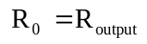 | (14.1)
The rate of drug output is given as the product of maintenance dose DM and first-order elimination rate constant KE.
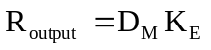 | (14.2)
For a zero-order constant rate infusion, the rate of output is also given as:
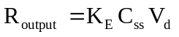 | (14.3)
Since ClT = KE Vd, the above equation can also be written as:
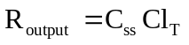 | (14.4a)
Or 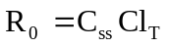 | (14.4b)
The bioavailability of a drug from controlled-release dosage form cannot be 100% as the total release may not be 100% and the drug may also undergo presystemic metabolism. Hence, if F is the fraction bioavailable, then:
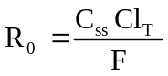 | (14.5)
and 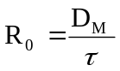 | (14.6)
Substituting equation 14.6 in equation 14.5 and rearranging, we get:
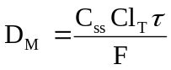 | (14.7)
where τ = dosing interval.
From the above equation, one can calculate the dose of drug that must be released in a given period of time in order to achieve the desired target steady-state concentration. It also shows that total systemic clearance is an important parameter in such a computation.
Since attainment of steady-state levels with a zero-order controlled drug release system would require a time period of about 5 biological half-lives, an immediate-release dose, DI, called as loading dose, may be incorporated in such a system in addition to the controlled-release components. The total dose, DT needed to maintain therapeutic concentration in the body would then be:
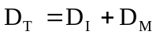 | (14.8)
The immediate-release dose is meant to provide the desired steady-state rapidly and can be calculated by equation:
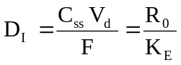 | (14.9)
The above equation ignores the possible additive effect from the immediate and controlled-release components. For many controlled-release products, there is no built-in loading dose.
The dosing interval for a drug following one-compartment kinetics with linear disposition is related to elimination half-life and therapeutic index TI according to equation:
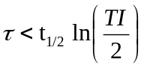 | (14.10)
Drug Release Patterns of Controlled
Delivery Dosage Forms
If one assumes that —
- Drug disposition follows first-order kinetics
- Rate-limiting step in the absorption is rate of drug release from the controlled-release formulation (i.e. Kr < Ka), and
- Released drug is rapidly and completely absorbed,
then, the four models for drug input based on the drug release pattern can be defined:
- Slow zero-order release
- Slow first-order release
- Initial rapid release of loading dose followed by slow zero-order release
- Initial rapid release of loading dose followed by slow first-order release.
The resulting profiles are depicted in Fig. 14.3.
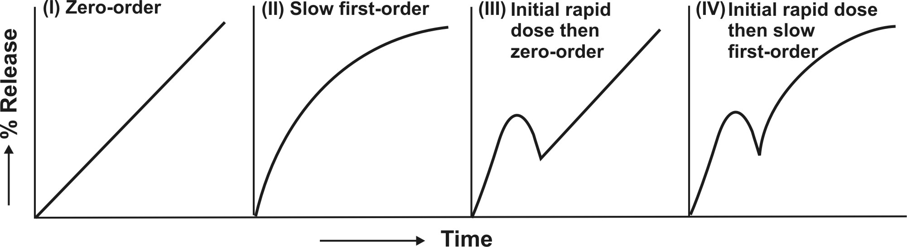
Fig. 14.3 Schematic representation of four major types of drug release characteristics from controlled-release formulations
Slow Zero-Order Release Systems
If the drug released from controlled-release formulations is stable in fluids at the absorption site, has similar absorption efficiency from all absorption sites and is absorbed rapidly and completely after its release, then, its rate of appearance in plasma will be governed by its rate of release from the controlled-release formulation. Thus, when the drug release follows zero-order kinetics, absorption will also be a zero-order process and concentration of drug in plasma at any given time can be given by equation:
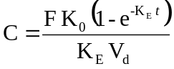 | (14.11)
where K₀ = zero-order release rate constant, also written as R0, the zero-order release rate.
The above equation is similar to the one that expresses the concentration-time course of a drug that shows one-compartment kinetics following constant rate i.v. infusion. The time to reach steady-state depends upon the elimination half-life of the drug. It is usually not possible with a single oral controlled-release dose to attain the plateau even with a drug having short half-life such as 3 hours since the mean GI residence time is around 12 hours. It takes 4.3 half-lives for attainment of 95% steady-state values. Thus, if t½ is 3 hours, about 13 hours will be required for the drug to reach plateau. Slower the elimination, (longer the t½), more the time required to reach steady-state. Once the desired steady-state is reached with repeated dosing of zero-order controlled-release formulation, minimal fluctuations will be observed. Zero-order release systems are thus ideal controlled delivery formulations.
Slow First-Order Release Systems
Such systems are easier to design but are inferior to zero-order systems especially when they are meant for oral use. This is because with first-order release characteristics, smaller and smaller amounts of drug are released as time passes and secondly, as the formulation advances along the GIT, the absorption efficiency generally decreases due to a number of reasons like decreased intestinal surface area, increased viscosity and decreased mixing. Thus, larger amounts of drug are needed to be released at a later stage when in fact the opposite happens with first-order systems.
The concentration of drug in plasma following administration of a controlled-release formulation with slow first-order release is given by equation:
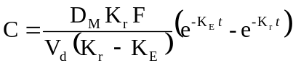 | (14.12)
When Kr < KE, flip-flop phenomena is observed which is a common feature for such controlled-release formulations. With repeated dosing of slow first-order release formulations, one generally observes a lower Cmax, higher Cmin and longer tmax in comparison to conventional release formulations.
Slow Zero-Order Release Systems with a Rapid Release Component
With such formulations, an initial dose is rapidly released (burst-effect) for immediate first-order availability while the remaining amount is released and absorbed at a slow zero-order rate. The equation for concentration-time course of such a formulation contains two portions, one each to denote rapid first-order release and slow zero-order release.
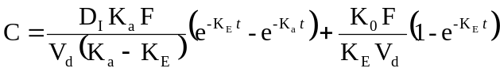 | (14.13)
Such a formulation is ideally suited for drugs with long t½ in which cases attainment of plateau would otherwise take a long time. The slow release component should ideally begin releasing the drug when the drug levels from the fast component are at a peak. However, the approach suffers from a big disadvantage when the formulation is meant for repetitive dosing — the blood level profile shows a peak-trough pattern (which normally does not result when all of the drug is released at a slow zero-order rate); this may cause a momentous rise in peak concentration immediately after each dose triggering toxic reactions (see Fig. 14.4). It is for this reason that such a design is unpopular.
The transient fluctuations in the peak concentration with these formulations can however be overcome by:
- Decreasing the loading dose in the subsequent dosage forms (which appears to be impractical),
- Increasing the dosing interval (this also seems to be tedious), or
- Administering an immediate-release conventional dosage form prior to repetitive dosing of zero-order controlled-release formulation instead of incorporating it in the latter.
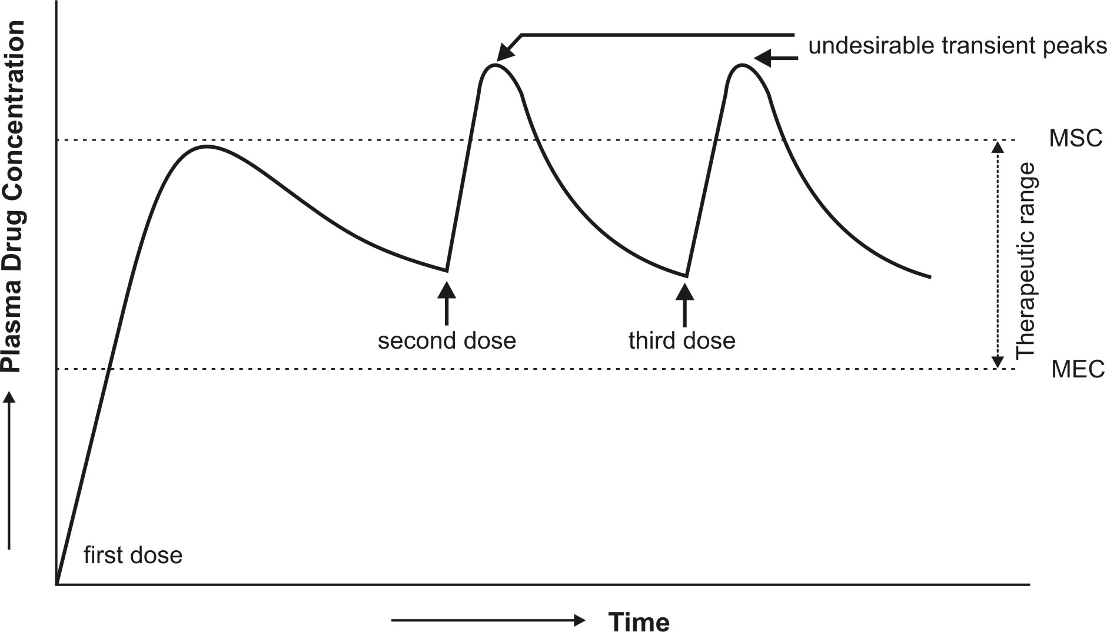
Fig. 14.4 Plasma concentration-time profile which results from repeated dosing of a controlled-release formulation with zero-order release and an initial fast release component.
Slow First-Order Release Systems with a Rapid Release Component
The equation describing the time course of plasma drug concentration with this type of formulation will also contain two portions—one to describe rapid first-order absorption and the other for slow first-order absorption from controlled-release portion.
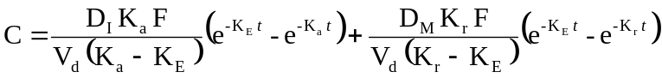 | (14.14)
As in the previous case, to obtain the desired plateau, the slow release component, DM should start releasing the drug:
- When the peak has been attained with rapid release dose, DI; this requires DM >> DI which results in wastage of drug since the absorption efficiency reduces as time passes and dosage form descends down the GIT, or
- When all of the DI has been released; this requires relatively small DM and therefore less drug wastage and better sustained levels despite fluctuations in drug levels (Fig. 14.5).
The problems that result from repeated dosing of this type of formulation are similar to that described for the third type of release pattern and can be handled in a similar manner.
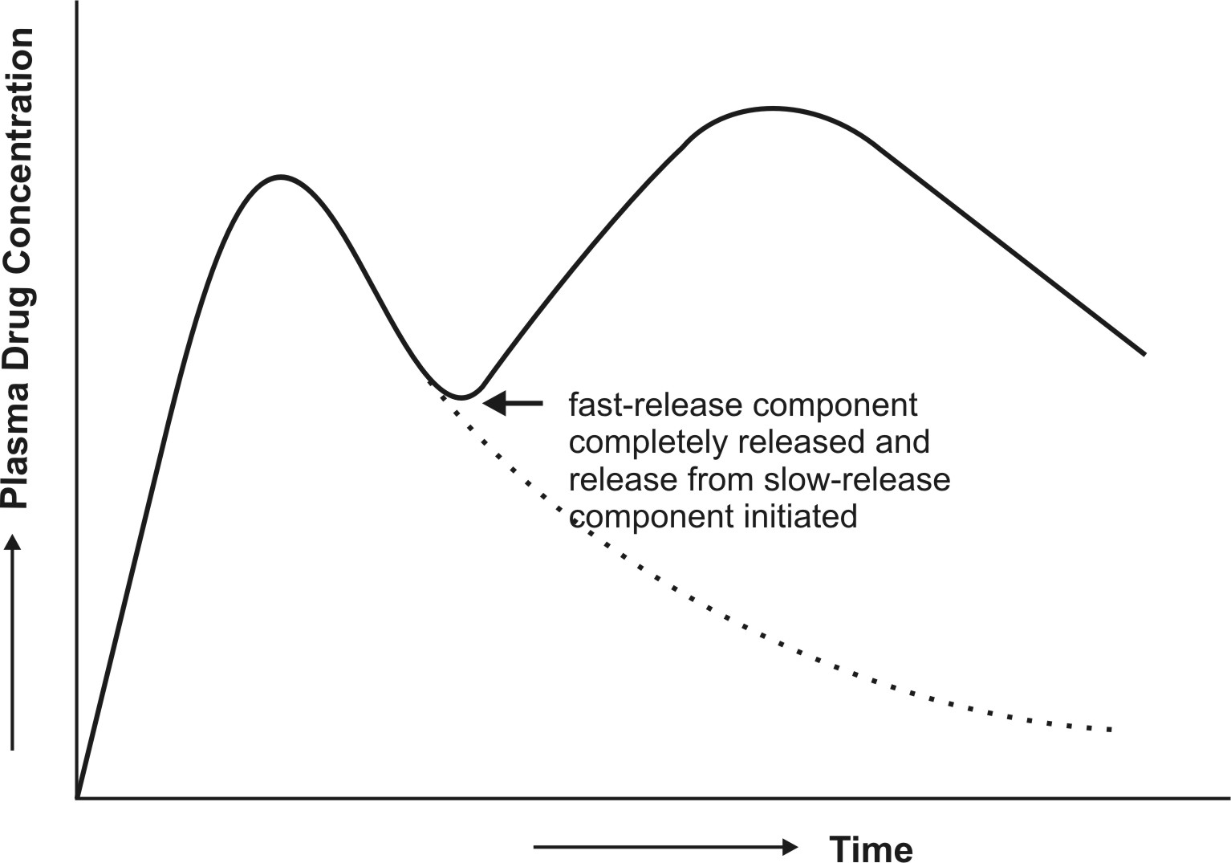
Fig. 14.5 Plasma concentration-time profile which results after a single oral dose of controlled-release drug delivery system containing a rapid release dose and a slow first-order release component
CLASSIFICATION OF CRDDS
cRDDS can be classified in various ways –
- On the basis of technical sophistication
- On the basis of route of administration.
On the basis of technical sophistication, CRDDS can be categorised into 4 major classes:
  - Rate-programmed DDS
  - Activation-controlled DDS
  - Feedback-controlled DDS
  - Site-targeted DDS
In the former three cases i.e. except site-targeted DDS, the formulation comprise of three basic components –
- The drug
- The rate controlling element
- Energy source that activates the DDS.

Rate-Programmed DDS
These DDS are those from which the drug release has been programmed at specific rate profiles. They are further subdivided into following subclasses:
  - Dissolution-controlled DDS
  - Diffusion-controlled DDS
  - Dissolution and diffusion-controlled DDS.
All the above systems can be designed in one of the following ways –
    - Reservoir systems (membrane-controlled DDS)
    - Matrix systems (soluble/erodible/swellable/degradable)
    - Hybrid systems (i.e. membrane cum matrix systems)

1. Dissolution-Controlled DDS
These systems are those where the rate-limiting phenomenon responsible for imparting the controlled-release characteristics to the DDS is either of the two -
(a) Slow dissolution rate of the drug - the drug present in such a system may be one of the following two types:
i. Drug with inherently slow dissolution rate e.g. griseofulvin, digoxin and nifedipine. Such drugs act as natural prolonged-release products, or
ii. Drug that transforms into slow dissolving forms on contact with GI fluids e.g. ferrous sulphate.
(b) Slow dissolution rate of the reservoir membrane or matrix - the drug present in such a system may be the one having high aqueous solubility and dissolution rate e.g. pentoxifylline and metformin. The challenge in designing such systems lies in controlling the drug dissolution rate by employing either or combination of following techniques –
- Embedment in slowly dissolving, degrading or erodible matrix. The matrix in addition may have low porosity or poor wettability.
- Encapsulation or coating with slow-dissolving, degrading or erodible substances. In this approach, the rate of dissolution fluid penetration and/or wettability of the reservoir system are controlled.
Slowly soluble and erodible materials commonly employed to achieve these objectives include hydrophobic substances such as ethyl cellulose (containing an added water-soluble release modifying agent such as PVP), polymethacrylates with pH independent solubility (e.g. Eudragit RS and RL 100) and waxes such as glyceryl monostearate, and hydrophilic materials like sodium CMC.

2. Diffusion-Controlled DDS
These systems are those where the rate-controlling step is not the dissolution rate of drug or release controlling element, but the diffusion of dissolved drug molecule through the rate-controlling element. The rate-controlling element in such a system is thus neither soluble, erodible nor degradable but is water-swellable or water-insoluble. Water-swellable materials include hydrophilic polymers and gums such as xanthan gum, guar gum, high viscosity grades of HPMC and HPC, alginates, etc. Water-insoluble polymers most commonly used in such systems are ethyl cellulose and polymethacrylates.
3. Dissolution and Diffusion-Controlled DDS
These systems are those where the rate of drug release is controlled by drug or polymer dissolution as well as drug diffusion i.e. the system is a combination of the two systems discussed above.
A summary of various approaches that are employed in the design of rate-programmed DDS is illustrated in figure 14.6.
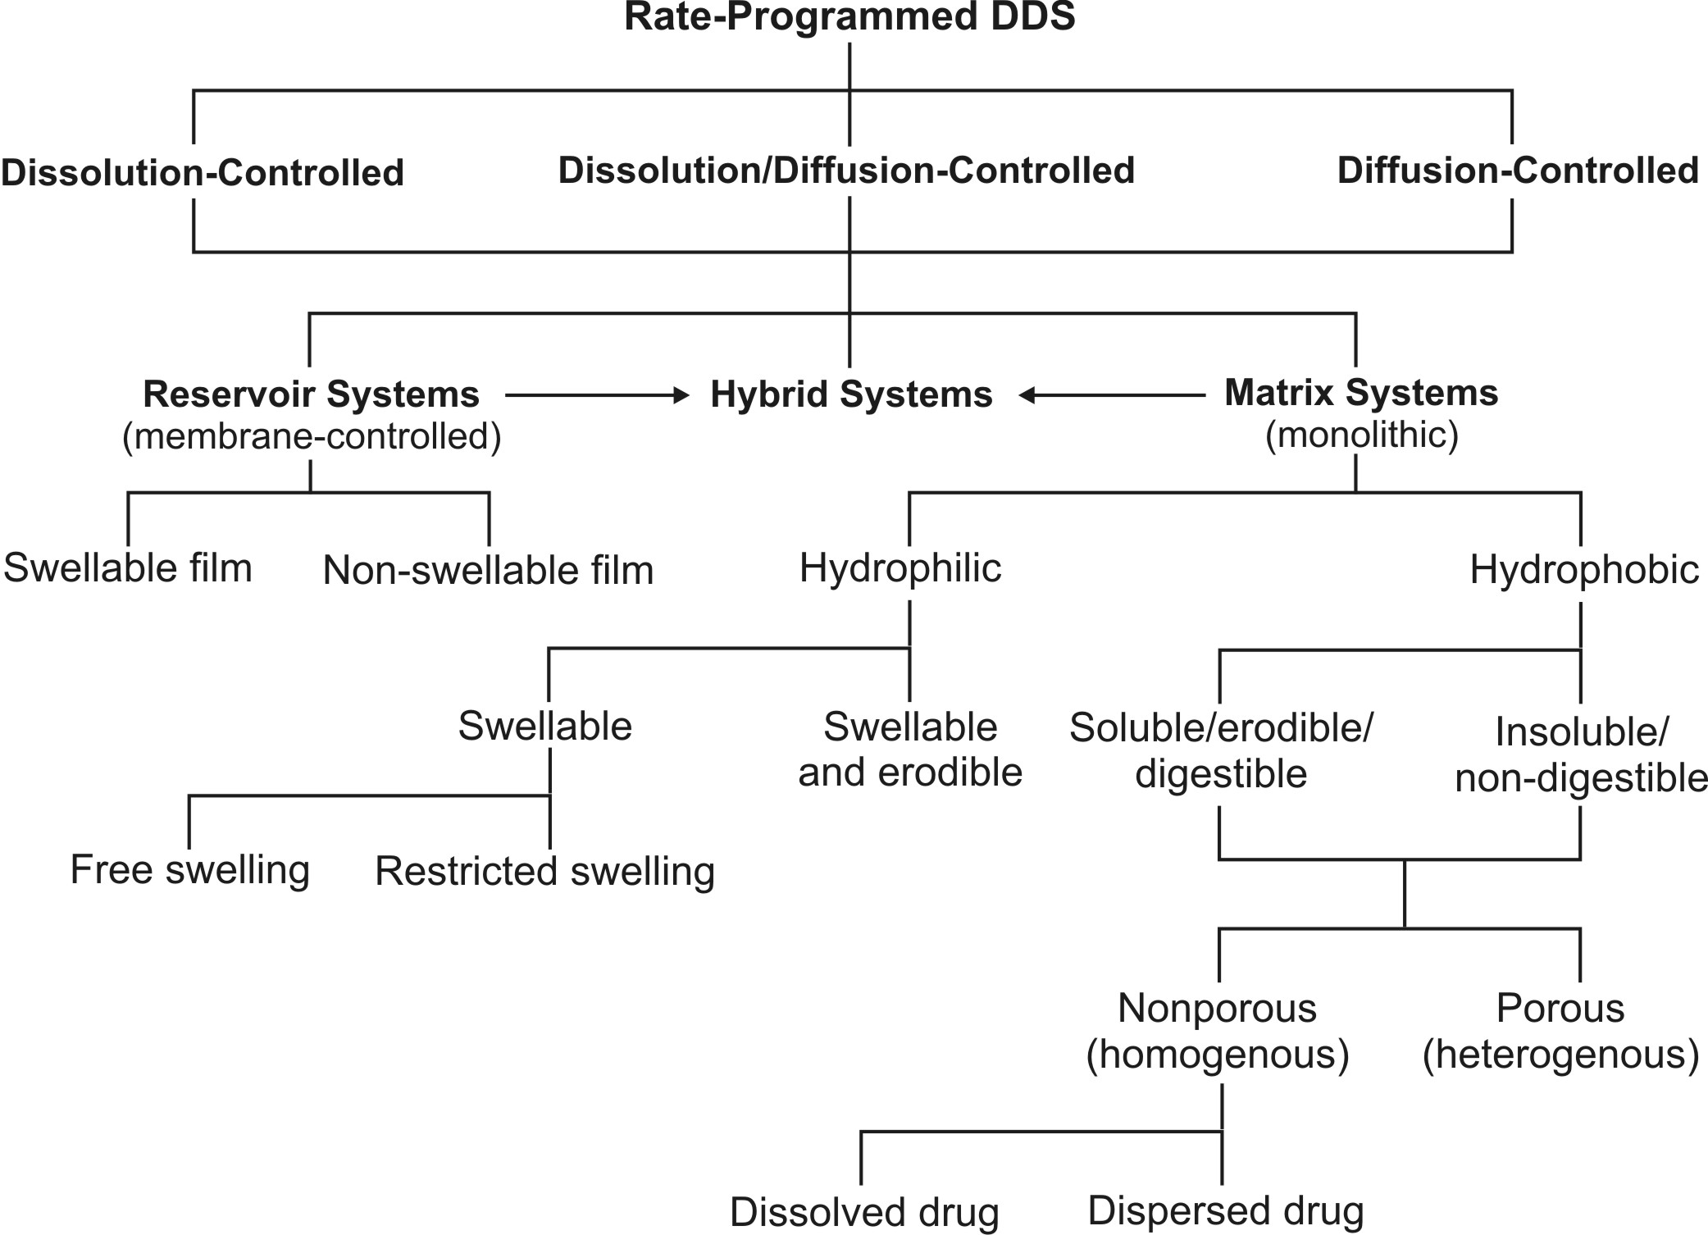
Fig. 14.6 Approaches in the design of rate-programmed DDS

- Reservoir systems (membrane-controlled DDS) – (see also Modern Pharmaceutics for advantages and disadv) These systems are those where the drug is present as a core in a compartment of specific shape encased or encapsulated with a rate-controlling wall, film or membrane having a well-defined thickness. The drug in the core must dissociate themselves from the crystal lattice and dissolve in the surrounding medium, partition and diffuse through the membrane.
Depending upon the physical properties of the membrane, two types of reservoir systems are possible –
  - Non-swelling reservoir systems – are those where the polymer membrane do not swell or hydrate in aqueous medium. Ethyl cellulose and polymethacrylates are commonly used polymers in such systems. Such materials control drug release owing to their thickness, insolubility or slow dissolution or porosity. Reservoir system of this type is most common and includes coated drug particles, crystals, granules, pellets, minitablets and tablets.
  - Swelling-controlled reservoir systems – are those where the polymer membrane swell or hydrate on contact with aqueous medium. In such systems drug release is delayed for the time period required for hydration of barrier and after attainment of barrier hydration, drug release proceeds at a constant rate. HPMC polymers are commonly employed in such systems.
- Matrix systems (monolithic DDS) – (see also Modern Pharmaceutics for advantages and disadv) These systems are those where the drug is uniformly dissolved or dispersed in release-retarding material. Such devices can be formulated as conventional matrix, or bi-or tri-layered matrix systems.
Depending upon the physical properties of the membrane, two types of matrix devices are possible –
  - Hydrophilic matrix – is the one where the release retarding material is a water swellable or swellable cum erodible hydrocolloid such as high molecular weight HPMCs, HPC, HEC, xanthan gum, sodium alginate, guar gum, locust bean gum, PEO (polyethylene oxide) and cross linked polymers of acrylic acid. Hydrophilic matrices are porous systems.
Depending upon the swelling behaviour of hydrophilic polymer, two types of matrices are possible –
    - Free-swelling matrix – is the one in which swelling is unhindered.
    - Restricted-swelling matrix – is the one in which the surface of the device is partially coated with an impermeable polymer film that restricts the hydration of swellable matrix material.
  - Hydrophobic matrix – is the one where the release retarding material is either –
- Slowly soluble, erodible or digestible, for e.g. waxes such as glyceryl monostearate, cetyl alcohol, hydrogenated vegetable oils, beeswax, carnauba wax, etc.
- Insoluble or non-digestible, for e.g. ethyl cellulose, polymethacrylates, etc.
Depending upon the manner of incorporation of drug in the matrix, hydrophobic matrices can be further classified as –
- Porous (heterogeneous) matrix – is the one where the drug and release-retarding matrix microparticles are simply mixed with each other and compressed into a tablet or the drug is dispersed in the polymer solution followed by evaporation of the solvent.
- Nonporous (homogeneous) matrix – is the one in which the release-retarding matrix material is first melted and the drug is then incorporated in it by thorough mixing followed by congealing the mass while stirring. Two types of nonporous matrix systems are possible –
  - Dissolved drug nonporous system – is the one where the drug is dissolved in the molten release-retarding matrix material.
  - Dispersed drug nonporous system – is the one where the quantity of drug is greater than its solubility in molten matrix polymer.
- Hybrid systems (membrane cum matrix DDS) – (see also Modern Pharmaceutics for advantages and disadv) These systems are those where the drug in matrix of release-retarding material is further coated with a release-controlling polymer membrane. Such a device thus combines the constant release kinetics of reservoir system with the mechanical robustness of matrix system.
Activation-Controlled DDS
In this group of CRDDSs, the release of drug molecules from the delivery systems is activated by some physical, chemical, or biochemical processes and/or facilitated by an energy supplied externally (Fig. 2 Chien article). The rate of drug release is then controlled by regulating the process applied or energy input. Based on the nature of the process applied or the type of energy used, these activation-controlled DDSs can be classified into following categories:
- Activation by Physical Processes
  - Osmotic pressure-activated DDS
  - Hydrodynamic pressure-activated DDS
  - Vapour pressure-activated DDS
  - Mechanical force-activated DDS
  - Magnetically-activated DDS
  - Sonophoresis-activated DDS
  - Iontophoresis-activated DDS
- Activation by Chemical Processes
  - pH-activated DDS
  - Ion-activated DDS
  - Hydrolysis-activated DDS
- Activation by Biochemical Processes
  - Enzyme-activated DDS

A. Physical Process-Activated DDS
1. Osmotic Pressure-Activated DDS
Osmotic systems release drug at a predetermined, typically zero-order rate, based on the principle of osmosis. Osmosis is natural movement of a solvent through a semipermeable membrane into a solution of higher solute concentration, leading to equal concentration of the solute on either sides of the membrane. Osmotic systems imbibe water from the body through a semipermeable membrane into an osmotic material which dissolves in it and increase in volume and generate osmotic pressure that results in slow and even delivery of drug through an orifice.
A semipermeable membrane (e.g. cellulose acetate) is the one that is permeable to a solvent (e.g. water) but impermeable to ionic (e.g. sodium chloride) and high molecular weight compounds.
In comparison to DDS based on diffusion and erosion, osmotic systems are more complex in design but provide better zero-order drug delivery.
2. Hydration/Hydrodynamic Pressure-Activated DDS
These systems are identical to osmotic systems that release drug at a zero-order rate. It however differs from osmotic system in that hydrodynamic pressure generating agent which is typically a water swellable hydrocolloid such as HPMC is contained in one compartment and the drug solution/dispersion in another collapsible reservoir. Both these compartments are housed in a rigid, shape retaining but water permeable housing. The hydrocolloid imbibes water and swells to generate hydrodynamic pressure that pushes the drug reservoir compartment and thus force the drug through an orifice at a slow and uniform rate.
3. Vapour Pressure-Activated DDS
These systems are identical to hydrodynamic systems in that the pumping compartment and the drug solution/dispersion compartment are separated by a freely movable partition and the whole system is enclosed in a rigid housing. The pumping compartment contains a liquefied compressed gas that vaporises at body temperature and creates vapour pressure that moves the partition to force the drug out of the device through a series of flow regulator and delivery cannula into the blood circulation at a constant rate. A typical example is the development infusion pump of heparin in anticoagulant therapy, of insulin in the control of diabetes and of morphine for patients suffering from the intensive pain of a terminal cancer.
4. Mechanical Force-Activated DDS
In these systems the drug reservoir is a solution in a container equipped with a mechanically activated pumping system. A metered dose of drug formulation can be reproducibly delivered into a body cavity, such as the nose, through the spray head upon manual activation of the drug-delivery pumping system. The volume of solution delivered is fixed and is independent of the force and duration of activation. A typical example of this type of drug-delivery system is the development of a metered-dose nebuliser for the intranasal administration of a precision dose of luteinizing hormone-releasing hormone (LHRH) and its synthetic analogues, such as buserelin.
5. Magnetically-Activated DDS
In these systems a tiny doughnut-shaped magnet is positioned in the centre of a hemispherical shaped drug-dispersing biocompatible polymer matrix and then coating the external surface of the medicated polymer matrix, with the exception of one cavity at the centre of the flat surface of the hemisphere, with a pure polymer, for instance, ethylene–vinyl acetate copolymer or silicone elastomers. This uncoated cavity is designed for allowing a peptide drug to release. When the magnet is activated, to vibrate by an external electromagnetic field, it releases the drug at a zero-order rate by diffusion process. (fig in Chien)
6. Sonophoresis-Activated DDS
This type of activation-controlled drug delivery system utilizes ultrasonic energy to activate or trigger the delivery of drugs from a polymeric drug delivery device. The system can be fabricated from either a non-degradable polymer, such as ethylene–vinyl acetate copolymer, or a bioerodible polymer, such as poly(lactide–glycolide) copolymer.

7. Iontophoresis-Activated DDS
This type of CRDDS uses electrical current to activate and modulate the diffusion of a charged drug molecule across a biological membrane, such as the skin, in a manner similar to passive diffusion under a concentration gradient but at a much faster rate. It is a painless procedure. Since like charges repel each other, application of a positive current drives positively charged drug molecules away from the electrode and into the tissues; and vice versa. (see fig. In book rev, what is iontophoresis, absorption of drug folder)
A typical example of this type of activation-controlled system is percutaneous penetration of anti-inflammatory drugs such as dexamethasone to surface tissues.

B. Chemical Process-Activated DDS
1. pH-Activated DDS
These systems are designed for acid-labile drugs or drugs irritating to gastric mucosa and target their delivery to the intestinal tract. It is fabricated by coating a core tablet of such a drug with a combination of intestinal fluid-insoluble polymer, like ethyl cellulose, and intestinal fluid-soluble polymer, like HPMCP. In the stomach, the coating membrane resists dissolution in pH 1-3. After gastric emptying, the system travels to the small intestine, and the intestinal fluid-soluble component in the coating membrane is dissolved in at pH above 5 thereby producing a microporous membrane that controls the release of drug from the core tablet. An example of such a system is oral controlled delivery of potassium chloride, which is highly irritating to gastric epithelium. (fig. Chien)
2. Ion-Activated DDS
Based on the principle that the GIT has a relatively constant level of ions, this type of system has been developed for controlling the delivery of an ionic or an ionisable drug at a constant rate. Such a CRDDS is prepared by first complexing an ionisable drug with an ion-exchange resin. A cationic drug is complexed with a resin containing SO₃⁻ group or an anionic drug with a resin containing N(CH₃)₃⁺ group. The granules of the drug–resin complex are further treated with an impregnating agent, like polyethylene glycol 4000, for reducing the rate of swelling upon contact with an aqueous medium. They are then coated by an air-suspension coating technique with a water-insoluble but water-permeable polymeric membrane, such as ethyl cellulose. This membrane serves as a rate-controlling barrier to modulate the release of drug from the CRDDS. In the GI tract, hydronium and chloride ions diffuse into the CRDDS and interact with the drug–resin complex to trigger the dissociation and release of ionic drug
Acidic drug release
Basic drug release
An example of such a formulation is liquid-oral with sustained release of a combination of hydrocodone and chlorpheniramine. (Fig. Chien).
3. Hydrolysis-Activated DDS
This type of CRDDS depends on the hydrolysis process to activate the release of drug molecules. In this system, the drug reservoir is either encapsulated in microcapsules or homogeneously dispersed in microspheres or nanoparticles prepared from bioerodible or biodegradable polymers such as polylactide, poly(lactide–glycolide) copolymer, poly(orthoester) or poly(anhydride). The release of a drug from the polymer matrix is activated by the hydrolysis-induced degradation of polymer chains, and the rate of drug delivery is controlled by polymer degradation rate. A typical example is injectable microspheres for the subcutaneous controlled delivery of luprolide, a potent biosynthetic analogue of gonadotropin-releasing hormone (GnRH) for the treatment of gonadotropin-dependent cancers, such as prostate carcinoma in men and endometriosis in the females, for up to 4 months. (Fig. Chien).

A. Biochemical Process-Activated DDS
1. Enzyme-Activated DDS
In this type of CRDDS, the drug reservoir is either physically entrapped in microspheres or chemically bound to polymer chains fabricated from biopolymers, such as albumins or polypeptides. The release of drugs is made possible by the enzymatic hydrolysis of biopolymers by a specific enzyme in the target tissue. A typical example is the development of albumin microspheres, which release 5-fluorouracil, in a controlled manner, by protease-activated biodegradation.

Feedback-Controlled DDS
In this group of CRDDSs, the release of drug molecules is activated by a triggering agent, such as a biochemical substance, in the body via some feedback mechanisms. The rate of drug release is regulated by the concentration of a triggering agent detected by a sensor built into the CRDDS. (fig chien)

1. Bioerosion-Activated DDS
This CRDDS consists of drug dispersed in a bioerodible matrix made of poly(vinyl methyl ether) half-ester, which is coated with a layer of immobilized urease. In a solution at neutral pH, the polymer erodes slowly. In the presence of urea, urease at the surface of the drug delivery system metabolizes urea to form ammonia. This causes the pH to increase which activates a rapid degradation of polymer matrix and subsequently release of drug molecules.

2. Bioresponsive DDS
In this CRDDS, the drug reservoir is contained in a device enclosed by a bioresponsive polymeric membrane whose permeability to drug molecules is controlled by the concentration of a biochemical agent in the tissue where the CRDDS is located. A typical example of this is the development of a glucose-triggered insulin delivery system, in which the insulin reservoir is encapsulated within a hydrogel membrane containing pendant NR₂ groups. In an alkaline solution, the NR₂ groups exist at neutral state and the membrane is not swollen and thus impermeable to insulin. As glucose penetrates into the membrane, it is oxidized enzymatically by the glucose oxidase entrapped in the membrane to form gluconic acid. This process triggers the protonation of NR₂ groups to form NR₂H⁺, and the hydrogel membrane becomes swollen and permeable to insulin molecules. The amount of insulin delivered is bioresponsive to the concentration of glucose penetrating into the CRDDS. (fig chien)

3. Self-Regulating DDS
This type of feedback-controlled DDS depends on a reversible and competitive binding mechanism to activate and to regulate the release of drug. The drug reservoir is a drug complex encapsulated within a semipermeable polymeric membrane. The release of drug from the CRDDS is activated by the membrane permeation of a biochemical agent from the tissue where the CRDDS is located. An example of this is development of self-regulating insulin delivery system that utilizes complex of glycosylated insulin–concanavalin A, which is encapsulated inside a polymer membrane. As glucose penetrates into the system, it activates the release of glycosylated insulin from the complex for a controlled release from the system. The amount of insulin released is thus self-regulated by the concentration of glucose that has penetrated into the insulin delivery system.

Site-Targeted DDS
Most conventional dosage forms deliver drug into the body that eventually reaches the site of action by multiple steps of diffusion and partitioning. In addition to the target site, the drug also distributes to non-target tissues that may result in toxicity or adverse reactions. Selective and targeted drug therapy could result in not just optimum and more effective therapy but also a significant reduction in drug dose and cost.
Targeted- or site-specific DDS refer to systems that place the drug at or near the receptor site or site of action.
Site-targeted DDS can be classified into three broad categories –
    - First-order targeting – refers to DDS that delivers the drug to the capillary bed or the active site
    - Second-order targeting – refers to DDS that delivers the drug to a special cell type such as the tumour cells and not to the normal cells
    - Third-order targeting – refers to DDS that delivers the drug intracellularly.

Site-targeted DDSs have also been characterized as –
- Passive targeting – refers to natural or passive disposition of a drug carrier based on the physicochemical characteristics of the system in relation to the body.
- Active targeting – refers to alterations of the natural disposition of the drug carrier, directing it to specific cells, tissues or organs; for e.g. use of ligands or monoclonal antibodies which can target specific sites.

Drug targeting often requires carriers for selective delivery and can serve following purposes –
      - Protect the drug from degradation after administration;
      - Improve transport or delivery of drug to cells;
      - Decrease clearance of drug; or
      - Combination of the above.
Carriers for drug targeting are of two types –
- Carriers covalently bonded to drug – where the drug release is required for pharmacological activity.
- Carriers not covalently bonded to drug – where simple uncoating of the drug is required for pharmacological activity; e.g. liposomes.
The various carriers used for drug targeting are –
        - Polymeric carriers
        - Albumin
        - Lipoproteins
        - Liposomes.

1. Polymeric Carrier Systems for Drug Targeting
The basic components of a polymeric targeted DDS are –
- A polymeric backbone which is non-immunogenic and biodegradable that contains following three attachments;
- A homing device, also called as site-specific targeting moiety, which is capable of leading the drug delivery system to the vicinity of a target tissue (or cell);
- A solubiliser, which enables the drug delivery system to be transported to and preferentially taken up by the target tissue; and
- A drug, which is covalently bonded to the polymeric backbone, through a spacer, and contains a linkage that is cleavable only by a specific enzyme(s) at the target tissue (fig. 14. 7).
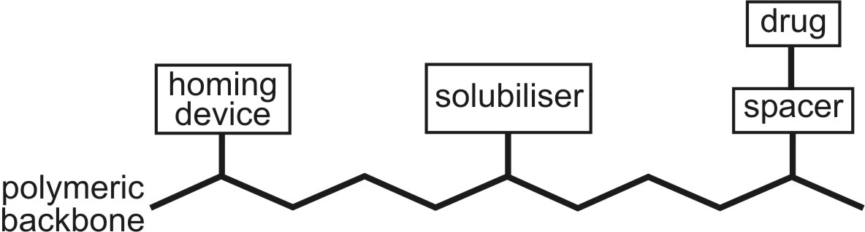
Fig. 14.7. Polymeric carrier system for drug targeting

Polymers used for drug targeting include polyethylenediamine, polylysine, chitosan, dextran and PEG for macromolecular drugs such as gene therapy. The homing device is a monoclonal antibody, a recognised sugar moiety or a small cell-specific ligand. At present, most site-specific DDS are limited to parenteral administration and primarily utilise soluble polymers.

Besides their use as regular carriers, polymers may also be formulated as microparticles or nanoparticles, wherein the drug is encapsulated in a biodegradable colloidal polymer. The small size of nanospheres allows good tissue penetration while providing protection or sustained release.

The disposition of micro- or nano-sphere depends upon their size –
- Particles > 12 μ are lodged in the capillary bed at the site of injection
- Particles from 2 – 12 μ are retained in lung, liver or spleen
- Particles < 0.5 μ (500 nm) deposit in spleen and bone marrow.

2. Albumin as Carrier for Drug Targeting
Although distribution of albumin is not site-specific, it has been conjugated with drugs such as methotrexate to increase duration of drug action and deliver drug to liver.

3. Lipoproteins as Carrier for Drug Targeting
Low-density lipoproteins enter cell by endocytosis and thus have the potential for transporting drugs into the cell in which lipoprotein-drug complex can be hydrolysed by lysosomal enzymes.

4. Liposomes as Carrier for Drug Targeting
Liposomes in the size range 0.5 – 100 μ have been used to reduce side effects and efficacy of drugs such as doxorubicin, amphotericin B, etc. The site-specificity to liposomes can be conferred by the type of lipid or by inclusion of a targeting agent such as monoclonal antibody into the liposomal bilayer.
endpoint

Oral Controlled Release Systems
Oral route has been the most popular and successfully used route for controlled delivery of drugs because of convenience and ease of administration, greater flexibility in dosage form design (possible because of versatility of GI anatomy and physiology) and ease of production and low cost of such a system.
The controlled-release systems for oral use are mostly solids and based on dissolution, diffusion or a combination of both mechanisms in the control of release rate of drug. Depending upon the manner of drug release, these systems are classified as follows:
A. Continuous Release Systems: These systems release the drug for a prolonged period of time along the entire length of GIT (especially up to the terminal region of small intestine) with normal transit of the dosage form. The various systems under this category are:
- Dissolution controlled release systems
- Diffusion controlled release systems
- Dissolution and diffusion controlled release systems
- Ion-exchange resin-drug complexes
- Slow dissolving salts and complexes
- pH-dependent formulations
- Osmotic pressure controlled systems
- Hydrodynamic pressure controlled systems
B. Delayed Transit and Continuous Release Systems: These systems are designed to prolong their residence in the GIT along with their release. Often, the dosage form is fabricated to detain in the stomach and hence the drug present therein should be stable to gastric pH. Systems included in this category are:
1. Altered density systems
2. Mucoadhesive systems
3. Size-based systems
C. Delayed Release Systems: The design of such systems involve release of drug only at a specific site in the GIT. The drugs contained in such a system are those that are:
- Destroyed in the stomach or by intestinal enzymes
- Known to cause gastric distress
- Absorbed from a specific intestinal site, or
- Intended to exert local effect at a specific GI site.
The two types of delayed release systems are:
- Intestinal release systems
- Colonic release systems
Dissolution Controlled Release Systems
Such systems are easiest to design. The drug present in such a system may be the one:
i. With inherently slow dissolution rate e.g. griseofulvin and digoxin; such drugs act as natural prolonged release products
ii. That produce slow dissolving forms when it comes in contact with GI fluids e.g. ferrous sulphate, or
iii. Having high aqueous solubility and dissolution rate e.g. pentoxifylline.
Drugs belonging to the last category present challenge in controlling their dissolution rate. The techniques employed are:
1. Embedment in slowly dissolving or erodible matrix, and
2. Encapsulation or coating with slowly dissolving or erodible substances (Fig. 14.6.).
Fig. 14.6 Schematic representation of dissolution controlled release systems —(a) matrix system, and (b) coated/encapsulated system
Matrix (or Monolith) Dissolution Controlled Systems
Matrix systems are also called as monoliths since the drug is homogeneously dispersed throughout a rate-controlling medium. They are very common and employ waxes such as beeswax, carnauba wax, hydrogenated castor oil, etc. which control drug dissolution by controlling the rate of dissolution fluid penetration into the matrix by altering the porosity of tablet, decreasing its wettability or by itself getting dissolved at a slower rate. The wax embedded drug is generally prepared by dispersing the drug in molten wax and congealing and granulating the same. The drug release is often first-order from such matrices.
Encapsulation/Coating Dissolution Controlled Systems (Reservoir Devices)
Here, the drug particles are coated or encapsulated by one of the several microencapsulation techniques with slowly dissolving materials like cellulose, PEGs, polymethacrylates, waxes, etc. The resulting pellets may be filled as such in hard gelatin capsules (popularly called as spansules) or compressed into tablets. The dissolution rate of coat depends upon the solubility and thickness of the coating which may range from 1 to 200 microns.
Diffusion Controlled Release Systems
In these types of systems, the rate-controlling step is not the dissolution rate but the diffusion of dissolved drug through a polymeric barrier. The drug release rate is never zero-order since the diffusional path length increases with time as the insoluble matrix is gradually depleted of drug. The two types of diffusion controlled systems are—matrix systems and reservoir devices.
Matrix Diffusion Controlled Systems
Here, the drug is dispersed in an insoluble matrix of rigid non-swellable hydrophobic materials or swellable hydrophilic substances. Materials used for rigid matrix are insoluble plastics such as PVC and fatty materials like stearic acid, beeswax, etc. With plastic materials, the drug is generally kneaded with the solution of PVC in an organic solvent and granulated. Waxy matrix is prepared by dispersing the drug in molten fat followed by congealing. The granules are then compressed into tablets (Fig. 14.7.a). Swellable matrix systems are popular for sustaining the release of highly water-soluble drugs. The material for such matrices are generally hydrophilic gums and may be of natural origin (guar gum, tragacanth), semisynthetic (HPMC, CMC, xanthan gum) or synthetic (polyacrylamides). The drug and the gum are granulated together with a solvent such as alcohol and compressed into tablets. The release of drug from such initially dehydrated hydrogels involves simultaneous absorption of water (resulting in hydration, gelling and swelling of gum) and desorption of drug via a swelling controlled diffusion mechanism. As the gum swells and the drug
Rate Controlling Step :
Diffusion of dissolved drug
through the matrix
Fig. 14.7 Diffusion controlled devices—(a) rigid matrix, and (b) swellable matrix
diffuses out of it, the swollen mass, devoid of drug appears transparent or glasslike and therefore the system is sometimes called as glassy hydrogel (Fig. 14.7b). The drug release follows Fickian first-order diffusion under equilibrium conditions. However, during the swelling process, such an equilibrium may not exist and the diffusion may be non-Fickian or anomalous diffusion.
Reservoir Devices (or Laminated Matrix Devices)
These systems are hollow containing an inner core of drug surrounded in a water insoluble polymer membrane. The polymer can be applied by coating or microencapsulation techniques. The drug release mechanism across the membrane involves its partitioning into the membrane with subsequent release into the surrounding fluid by diffusion (Fig. 14.8). The polymers commonly used in such devices are HPC, ethyl cellulose and polyvinyl acetate. A disadvantage of all such microencapsulated drug release systems is a chance of sudden drug dumping which is not common with matrix devices.
Rate Controlling Factors:
Polymeric content in coating,
Thickness of coating,
Hardness of microcapsule
Fig. 14.8 Drug release by diffusion across the insoluble membrane of reservoir device
Dissolution and Diffusion Controlled Release Systems
In such systems, the drug core is encased in a partially soluble membrane. Pores are thus created due to dissolution of parts of the membrane which:
- Permit entry of aqueous medium into the core and hence drug dissolution, and
- Allow diffusion of dissolved drug out of the system (Fig. 14.9).
An example of obtaining such a coating is using a mixture of ethyl cellulose with PVP or methyl cellulose; the latter dissolves in water and creates pores in the insoluble ethyl cellulose membrane.
Rate Controlling Factor :
Fraction of soluble polymer
in the coat
Fig. 14.9 Dissolution and diffusion controlled release system
Ion-Exchange Resin-Drug Complexes
Controlled delivery of ionisable acidic and basic drugs can be obtained by complexing them with insoluble nontoxic anion exchange and cation exchange resins respectively. The drug is released slowly by diffusion through the resin particle structure. The following equation represents the release of a basic drug, NH2R', from a cation exchange resin RSO3H when in contact with GI fluid containing an ionic compound A+B- (either gastric HCl or intestinal NaCl):
RSO3–NH3+R' + A+B– ⎯→ RSO3-A+ + NH3+R'B–
A number of basic drugs like noscapine, phenylpropanolamine and phentermine have been retarded by such an approach. The complex can be prepared by incubating the drug-resin solution or passing the drug solution through a column containing ion-exchange resin. The drug-resin complex can be coated with cellulose or hard paraffin and formulated as ion free suspension for paediatric use.
Slow Dissolving Salts and Complexes
Salts or complexes of drugs which are slowly soluble in the GI fluids can be used for controlled-release of the active principle. Amine drugs can be reacted with tannic acid to form poorly soluble complexes that can be formulated as long acting tablets. Penicillin G has been complexed with N,N’-dibenzyl ethylenediamine to give benzathine penicillin G that can be formulated as oral suspension. Such complexes can be obtained by simple acid-base reaction on mixing together solutions of individual compounds.
pH-Independent Formulations
Such systems are designed to eliminate the influence of changing GI pH on dissolution and absorption of drugs by formulating them with sufficient amount of buffering agents (salts of phosphoric, citric or tartaric acids) that adjust the pH to the desired value as the dosage form passes along the GIT and permit drug dissolution and release at a constant rate independent of GI pH. The dosage form containing drug and buffer is coated with a permeable substance that allows entry of aqueous medium but prevents dispersion of tablet.
Osmotic Pressure Controlled Systems
Unlike the solution-diffusion mechanism for most systems, an oral osmotic pump, popularly called as oros, works on the principle of osmotic pressure to release the drug at a constant zero-order rate. A core comprising of drug and an osmotically active substance (also called as osmogen) such as potassium chloride or mannitol is surrounded by a rigid semipermeable membrane coating such as cellulose ester or cellulose ether having an orifice of 0.4 mm diameter produced by laser beam for drug exit. When exposed to GI fluids, water flows through the semipermeable membrane into the tablet due to osmotic pressure difference which dissolves the drug and pumps it out through the orifice by the osmotic force (Fig. 14.10). Such devices can be used to target specific areas of the GIT.
Rate Controlling Factors :
Orifice diameter
Membrane area
Membrane thickness
Membrane permeability
Osmotic properties of the core
Drug solubility
Fig. 14.10 Oral osmotic pump (oros)
The oros principle can be used to design multiunit dosage forms consisting of drug core particles coated with a water permeable membrane in which the delivery orifice is made by using a channelling agent such as PVP and the coated particles filled in a capsule.
Hydrodynamic Pressure Controlled Systems
The hydrodynamic pressure generated by swelling of a hydrophilic gum can also be used to activate the delivery of drugs. The device comprises of a rigid, shape retaining housing enclosing a collapsible, impermeable compartment containing liquid drug (Fig. 14.11). The space between the external housing and the drug compartment contains a layer of swellable, hydrophilic gum such as polyhydroxyalkyl methacrylate. In the GIT, the gum imbibes water through the opening present at the lower side of external housing and swells creating a hydrodynamic pressure. The pressure thus created squeezes the collapsible drug reservoir to release the medicament through the delivery orifice at a zero-order rate. Such systems are also called as push-pull osmotic pumps.
Rate Controlling Factors :
Fluid permeability
Surface area of wall with openings
Hydrodynamic pressure gradient
Fig. 14.11 Hydrodynamic pressure controlled system (push-pull osmotic pump)
Altered Density Systems
The transit time of GI contents is usually less than 24 hours. This is the major limiting factor in the design of oral controlled-release formulations which can reduce the frequency of dosing to a time period little more than the residence time of drug. However, if the residence time of drug in the stomach and/or intestine is prolonged in some way, the frequency of dosing can be further reduced. There are 3 ways by which this can be achieved—altering the density of drug particles, use of mucoadhesive polymers and altering the size of the dosage form. The altered density approach involves use of either high or low density pellets.
High Density Pellets
The density of GI fluids is around 1.4 g/cc. Use of drug pellets having density greater than this value, preferably above 1.6 g/cc, results in prolonged GI residence that is unaffected by food. Iron oxide, titanium dioxide and barium sulfate have been used to increase the density of drug pellets. The drug is coated on the heavy core and then covered by a diffusion controlled membrane (Fig. 14.12a).
Low Density Pellets
Also called as hydrodynamically balanced systems, such pellets, having density less than that of GI fluids, float on the gastric juice for an extended period of time while slowly releasing the drug. Globular shells such as that of poprice and celluloses have been used to lower the density of system (Fig. 14.12b). A swellable gum like HPMC can be used for a similar purpose (Fig. 14.12c).
Fig. 14.12 Altered density systems
Floating or buoyant tablets/capsules can be formulated by granulating a drug with 20 to 80% of hydrogel such as HPMC, HEC and HPC. On contact with GI fluids, the tablet swells and forms a diffusible gel barrier that lowers the density of system to less than 1 allowing it to float. Lipophilic polymers such as silicone elastomer can also be modified to have swelling properties. This is achieved by impregnating a water miscible liquid such as glycerol or a water-soluble salt such as sodium chloride in the lipophilic matrix. On contact with aqueous medium, the modified lipophilic polymer swells due to absorption of water by the hydrophilic additives in the matrix. Alternatively, a gas filled flotation chamber can be attached to a membrane coated tablet for making it buoyant.
Mucoadhesive Systems
A bioadhesive polymer such as cross-linked polyacrylic acid, when incorporated in a tablet, allows it to adhere to the gastric mucosa or epithelium. Such a system continuously releases a fraction of drug into the intestine over prolonged periods of time.
Size-Based Systems
Gastric emptying of a dosage form can be delayed in the fed state if its size is greater than 2 mm. Dosage form of size 2.5 cm or larger is often required to delay emptying long enough to allow once daily dosing. Such forms are however difficult to swallow.
Intestinal Release Systems
A drug may be enteric coated for intestinal release for several known reasons such as to prevent gastric irritation, prevent destabilization in gastric pH, etc. Certain drugs are delivered to the distal end of small intestine for absorption via Peyer’s patches or lymphatic system. Peyer’s patches are mucosal lymphoid tissues that are known to absorb macromolecules like proteins and peptides and antigens by endocytosis. Selective release of such agents to Peyer’s patch region prevents them from getting destroyed/digested by the intestinal enzymes. Such a site can be utilized for oral delivery of insulin. Lymphatic system on the other hand is known to absorb highly lipophilic agents directly into the systemic circulation without their first-pass through liver. The drug is absorbed by two mechanisms—chylomicrons which are fatty vesicles that entrap hydrophobic drugs, and pinocytic uptake of macromolecules.
Colonic Release Systems
Drugs are poorly absorbed through colon but may be delivered to such a site for two reasons—
  - Local action as in the treatment of ulcerative colitis with mesalamine, and
  - Systemic absorption of protein and peptide drugs like insulin and vasopressin.
Advantage is taken of the fact that pH-sensitive bioerodible polymers like polymethacrylates release the medicament only at the alkaline pH of colon or use of divinylbenzene cross-linked polymers that can be cleaved only by the azoreductase of colonic bacteria to release free drug for local effect or systemic absorption.
PARENTERAL CONTROLLED RELEASE SYSTEMS
One of the major advantages of parenteral controlled drug delivery systems is that the duration of action can be extended for days or months and sometimes upto a year. The prime drawback is that, once administered, the drug cannot be easily removed if an undesirable action is precipitated or if the drug is no longer needed. Most of such systems are administered by subcutaneous and intramuscular routes and few by intravenous and intraperitoneal routes. Subcutaneous route is limited to well absorbed water-soluble drugs like insulin and dose volume is limited to 0.5 to 1.5 ml. Deep intramuscular route is suitable for polymeric systems or slightly soluble drugs, the volume size restricted to 2 ml. Intravenous route is useful for administration of liposomes, nanoparticles, erythrocytes and polypeptides. An important criteria for this route is drug particle size. A disadvantage of i.v. route is that the system may be taken up by the reticuloendothelial system but the same can be put to use in targeting drugs to such a system. Intraperitoneal route is important in targeting of antineoplastics into the lymphatic system.
The vehicle, polymers and other substances used in the formulation of parenteral controlled-release dosage forms should be sterile, pyrogen free, nonirritating, biocompatible and biodegradable into nontoxic compounds within an appropriate time, preferably close to the duration of drug action.
There are several approaches to achieve controlled drug delivery via parenteral route, the release being controlled by dissolution, diffusion, dissociation, partitioning or bioerosion. The systems can be broadly classified as:
A. Injectables:
1. Solutions
2. Dispersions
3. Microspheres and Microcapsules
4. Nanoparticles and Niosomes
5. Liposomes
6. Resealed Erythrocytes
B. Implants
C. Infusion Devices:
1. Osmotic Pumps
2. Vapor Pressure Powered Pumps
3. Battery Powered Pumps
Solutions
Both aqueous as well as oil solutions may be used for controlled drug release. With aqueous solutions (given intramuscularly), the drug release may be controlled in three ways:
i. By increasing the viscosity of vehicle by use of MC, CMC or PVP and thus, decreasing molecular diffusion and localizing the injected drug.
ii. By forming a complex with macromolecules like MC, CMC or PVP from which the drug dissociates at a controlled rate (only free drug will get absorbed).
iii. By forming complexes that control drug release not by dissociation but by reducing the solubility of parent drug e.g. protamine zinc insulin and cyanocobalamin zinc tannate.
Oil solutions control the release by partitioning the drug out of the oil in the surrounding aqueous biofluids. Vegetable oils like arachis oil, cottonseed oil, etc. are used for such a purpose. The method is applicable only to those drugs which are oil soluble and have optimum partition coefficient.
Dispersions
Dispersed systems like emulsions and suspensions can be administered by i.m., s.c. or i.v. routes. Among emulsions, the o/w systems have not been used successfully since absorption of drug incorporated in the oil phase is rapid due to large interfacial area and rapid partitioning. Similarly, few w/o emulsions of water-soluble drugs have been tried for controlled-release. Multiple emulsions of w/o/w and o/w/o types (more correctly, double emulsions) are becoming popular since an additional reservoir is presented to the drug for partitioning which can effectively retard its release rate (Fig. 14.13).
Control of drug release from suspensions is easier and predictable. Drug dissolution and subsequent diffusion are the main rate controlling steps. Release of water-soluble drugs can be retarded by presenting it as oil suspension and vice versa for oil soluble drugs. Factors to be considered in the formulation of such a system include -
i. Solid content : should be ideally in the range 0.5 to 5.0%
ii. Particle size : this factor is very important since larger the particle size, slower the dissolution; however, larger particles have their own disadvantages like causing irritation at the injection site (size should therefore be below 10 microns), poor syringeability and injectability and rapid sedimentation. The latter problem can be overcome by use of viscosity builders which also retard drug diffusion.
Fig. 14.13 Multiple emulsions for parenteral controlled-release systems
Aqueous suspensions can be given by i.m. or s.c. routes. Generally crystalline and stable polymorphic forms of the drug are chosen rather than amorphous forms to delay release. Solubility can be further reduced by salt or complex formation e.g. crystalline zinc insulin shows more prolonged action than amorphous zinc insulin complex. Oil suspensions, generally given i.m., prolong drug action much more in comparison to oil solution and aqueous suspension since drug release involves two rate- limiting steps viz. dissolution of drug particles, and partitioning of the dissolved drug from oil to the aqueous biofluids.
Microspheres and Microcapsules
Microspheres are free flowing powders consisting of spherical particles of size ideally less than 125 microns that can be suspended in a suitable aqueous vehicle and injected by an 18 or 20 number needle. Each particle is basically a matrix of drug dispersed in a polymer from which release occurs by a first-order process. The polymers used are biocompatible and biodegradable e.g. polylactic acid, polylactide coglycolide, etc. Drug release is controlled by dissolution/degradation of matrix. Small matrices release drug at a faster rate and thus, by using particles of different sizes, various degrees of controlled-release can be achieved. The system is ideally suited for controlled-release of peptide/protein drugs such as LHRH which have short half-lives and otherwise need to be injected once or more, daily, as conventional parenteral formulations. In comparison to peptides, proteins are difficult to formulate because of their higher molecular weight, lower solubility and the need to preserve their conformational structure during manufacture.
In order to overcome uptake of intravenously administered microspheres by the reticuloendothelial system and promote drug targeting to tumors with good perfusion, magnetic microspheres were developed. They are prepared from albumin and magnetite (Fe2O3) and have a size of 1.0 micron to permit intravascular injection. The system is infused into an artery that perfuses the target site and a magnet is placed over the area to localize it in that region. A 100 times higher concentration of doxorubicin was attained at the target site by such an approach with just half the i.v. dose.
Microcapsules differ from microspheres in that the drug is centrally located within the polymeric shell of finite thickness and release may be controlled by dissolution, diffusion or both. Quality microcapsules with thick walls generally release their medicaments at a zero-order rate. Steroids, peptides and antineoplastics have been successfully administered parenterally by use of controlled-release microcapsules.
Nanoparticles and Niosomes
Nanoparticles are also called as nanospheres or nanocapsules depending upon whether the drug is in a polymer matrix or encapsulated in a shell. They differ from microspheres in having submicron particles in the nanometer size range—10 to 1000 nm. The polymers used are the usual biodegradable ones. The main advantage of this system is that it can be stored for upto 1 year and can be used for selective targeting via reticuloendothelial system to liver and to cells that are active phagocytically.
Like nanoparticles, niosomes are inexpensive alternatives to liposomes. They are closed vesicles formed in aqueous media from nonionic surfactants with or without the presence of cholesterol or other lipids.
Liposomes
The term liposomes (meaning lipid body) was derived on the basis of names of subcellular particles like lysosome and ribosome. It is defined as a spherule/vesicle of lipid bilayers enclosing an aqueous compartment. The lipid most commonly used is phospholipid. Sphingolipids, glycolipids and sterols have also been used to prepare liposomes. Their size ranges from 25 to 5000 nm. Depending upon their structure, liposomes are classified as:
i. MLV (multilamellar vesicles) : These liposomes are made of series of concentric bilayers of lipids enclosing a small internal volume.
ii. OLV (oligolamellar vesicles) : These are made of 2 to 10 bilayers of lipids surrounding a large internal volume.
iii. ULV (unilamellar vesicles) : These are made of single bilayer of lipids. They may be SUV (small unilamellar vesicles) of size 20 to 40 nm, MUV (medium unilamellar vesicles) of size 40 to 80 nm, LUV (large unilamellar vesicles) of size 100 to 1000 nm or GUV (giant unilamellar vesicles) of size greater than 1000 nm.
A large variety of drugs (antineoplastics, antibiotics), peptides/proteins (including antibodies) and viruses and bacteria can be incorporated into liposomes. Water-soluble drugs are trapped in the aqueous compartment while lipophilic ones are incorporated in the lipid phase of liposomes. Because of their availability in various sizes, ability to incorporate both water as well as oil soluble drugs, their inertness and their ability to protect labile drugs, liposomes are versatile carriers for parenteral drug delivery systems. Intramuscularly and subcutaneously injected liposomes deliver drug at a controlled rate while intravenous administration selectively targets them to reticuloendothelial system and phagocytic cells. A simple method by which liposomes can be produced involves drying an organic solvent solution of lipids onto the wall of a flask/beaker followed by hydration and dispersion of lipid by addition of buffer and mixing (Fig. 14.14).
Fig. 14.14 Production procedure for liposomes.
Resealed Erythrocytes
Drug loading in body’s own erythrocytes when used to serve as controlled delivery systems have several advantages. They are fully biodegradable and biocompatible, nonimmunogenic, can circulate intravascularly for days (act as circulatory drug depots) and allow large amounts of drug to be carried. The drug need not be chemically modified and is protected from immunological detection and enzymatic inactivation. Drug loading can be done by immersing the cells in buffered hypotonic solution of drug which causes them to rupture and release hemoglobin and trap the medicament. On restoration of isotonicity and incubation at 37o C, the cells reseal and are ready for use (Fig. 14.15).
Fig. 14.15 Drug loading in erythrocytes.
Damaged erythrocytes are removed by the liver and spleen. These organs can thus be specifically targeted by drug loaded erythrocytes.
Implants
An ideal implantable parenteral system should possess following properties—
1. Environmentally stable : should not breakdown under the influence of heat, light, air and moisture.
2. Biostable : should not undergo physicochemical degradation when in contact with biofluids (or drugs).
3. Biocompatible : should neither stimulate immune responses (otherwise the implant will be rejected) nor thrombosis and fibrosis formation.
4. Nontoxic and noncarcinogenic : its degradation products or leached additives must be completely safe.
5. Should have a minimum surface area, smooth texture and structural characteristics similar to the tissue in which it is to be implanted to avoid irritation.
6. Should be removable when required.
7. Should release the medicament at a constant predetermined rate for a predetermined period of time.
Some of the important advantages of implants over injectable controlled-release formulations are—
1. More effective and more prolonged action (for over a year).
2. A significantly small dose is sufficient.
A major disadvantage of such systems is that a microsurgery is required for implantation of device. Some devices can be easily implanted by use of a specially designed implanter syringe. The devices are generally implanted subcutaneously or intramuscularly. Subcutaneous tissue is an ideal location because of its easy access to implantation, poor perfusion, slow drug absorption and low reactivity towards foreign materials.
The drug may be dissolved, dispersed or embedded in a matrix of polymers that control release by dissolution, diffusion or both, bioerosion, biodegradation or an activation process such as osmosis or hydrolysis. The system is generally prepared as implantable flexible/rigid moulded or extruded rods, spherical pellets or compressed tablets. Polymers used are silicone elastomers, polymethacrylates, polycaprolactone, polylactide/glycolide, etc. Drugs generally presented in such systems are steroids like contraceptives (megestrol acetate, norgestrone, etc.), morphine antagonists like naltrexone for opiod-dependent addicts, etc.
Infusion Devices
These are also implantable devices but are versatile in the sense that they are intrinsically powered to release the medicament at a zero-order rate and the drug reservoir can be replenished from time to time. Depending upon the mechanism by which these implantable pumps are powered to release the contents, they are classified into following types:
1. Osmotic pressure activated drug delivery systems
2. Vapor pressure activated drug delivery systems
3. Battery powered drug delivery systems
Osmotic Pumps (Alzet)
These pumps are capsular in shape and made in a variety of sizes. The device is shown in Fig. 14.16.
The pump is made of three concentric layers—the innermost drug reservoir contained in a collapsible impermeable polyester bag (which is open to the exterior via a single portal) followed by a sleeve of dry osmotic energy source (sodium chloride) and the outermost rigid, rate-controlling semipermeable membrane fabricated from substituted cellulosic polymers. A rigid polymeric plug is used to form a leakproof seal between the drug reservoir and the semipermeable housing. An additional component, the flow modulator, comprising of a cap and a tube made of stainless steel is inserted into the body of osmotic pump after filling. After implantation, water from the surrounding tissue fluids is imbibed through the semipermeable membrane at a controlled rate that dissolves the osmogen creating an osmotic pressure differential across the membrane. The osmotic sleeve thus expands and since the outer wall is rigid, it squeezes the inner flexible drug reservoir and drug solution is expelled in a constant volume per unit time fashion. The drug delivery continues until the reservoir is completely collapsed. Ionized drugs, macromolecules, steroids and peptides (insulin) can be delivered by such a device.
Rate Controlling Factors :
Porosity of semipermeable membrane
Osmotic pressure difference across the membrane
Fig. 14.16 Cross section of osmotic pump
Vapour Pressure Powered Pump (Infusaid)
This device is based on the principle that at a given temperature, a liquid in equilibrium with its vapour phase exerts a constant pressure that is independent of enclosing volume. The device is shown in Fig. 14.17.
The disc shaped device consists of two chambers—an infusate chamber containing the drug solution which is separated by a freely movable flexible bellow from the vapour chamber containing inexhaustible vaporizable fluid such as fluorocarbons. After implantation, the volatile liquid vaporizes at the body temperature and creates a vapour pressure that compresses the bellows and expels the infusate through a series of flow regulators at a constant rate. Insulin for diabetics and morphine for terminally ill cancer patients have been successfully delivered by such a device.
Fig. 14.17 Cross section of vapor pressure driven device
Battery Powered Pumps
Two types of battery powered implantable programmable pumps used successfully to deliver insulin are—peristaltic pump and solenoid driven reciprocating pump, both with electronic controls. The systems can be programmed to deliver drug at desired rates. Their design is such that the drug moves towards the exit and there is no backflow of the infusate.
TRANSDERMAL DRUG DELIVERY SYSTEMS
Transdermal delivery systems are topically administered medicaments in the form of patches that deliver drugs for systemic effects at a predetermined and controlled rate. Some of the advantages of these systems over other controlled-release formulations are:
1. Drugs with very short half-lives e.g. nitroglycerine when administered as transdermal patches, release medicaments at a constant rate for a time period more than that obtainable with oral formulations.
2. Drugs with narrow therapeutic indices can be safely administered since better control of release is possible.
3. The noninvasive nature of these systems permits easy removal and termination of drug action in situations of toxicity.
4. Problems encountered with oral administration like degradation, gastric irritation, first-pass effect, etc. are avoided.
The route is unsuitable when —
    - Drug dose is large
    - Drug has large molecular size (makes absorption difficult; should ideally be below 800-1000)
    - Drug is skin sensitising and irritating
    - Drug is metabolized in skin
    - Drug undergoes protein binding in skin
    - Drug is highly lipophilic or hydrophilic (should be moderately soluble in both oil and water).
Other disadvantages of such systems include variation in absorption efficiency at different sites of skin, difficulty of adhesion to certain skin types and length of time for which a patch can be left on any area due to permeability changes (usually not more than 7 to 10 days).
Several types of transdermal drug delivery devices are available but they can be basically divided into two broad categories based on the mechanism by which drug release is controlled:
1. Monolithic (or matrix) systems.
2. Reservoir (or membrane) systems.
All such devices are fabricated as multilayer laminate structures in which the drug-polymer matrix or a drug reservoir is sandwiched between two polymeric layers. The outer layer, called as backing layer, is impermeable and meant to prevent drug loss through it. It is generally composed of metallized plastic. The other layer which contacts the device with the skin is adhesive layer. It is permeable and in some cases, may act as rate-limiting membrane. It is generally made of pressure sensitive adhesive materials like acrylic copolymers, polyisobutylene and polysiloxane or contact adhesives.
The choice of monolithic or reservoir type of system for controlling drug release depends upon the major rate-limiting step in the absorption of drug from such devices. The two rate-limiting steps are:
1. Rate of drug diffusion from the device, R1, and
2. Rate of drug permeation through the stratum corneum, R2.
The overall rate of drug transport is proportional to the sum (R1 + R2).
Monolithic (or Matrix) Devices
These devices are used when R2 is the rate-controlling step (R2 < R1) and the drug has a large therapeutic index so that overdosing does not precipitate toxic reactions. The two categories of matrix devices are—one in which the drug is dissolved (usually below saturation levels) in the polymer matrix and the other in which the drug is dispersed (generally much above saturation levels). The polymers employed for matrix systems may be hydrophilic or lipophilic and includes PVC, PVP, polysaccharides, polyesters, microporous polypropylene and ethylene vinyl acetate copolymers. The drug release rate from matrix systems is rapid
Rate Controlling Factors :
Drug concentration in
polymer matrix
Chemical nature of
polymer matrix
Geometry of device
Fig. 14.18 Schematic representation of a monolith (matrix) transdermal drug delivery system
initially and falls as the matrix gets depleted of drug. The rate is thus proportional to the square root of time. Fig. 14.18. shows a typical matrix system.
Reservoir (or Membrane) Devices
These devices are used when drug permeation rate is rapid and absorption should therefore be controlled by controlling drug release (R1 < R2). It is also suitable for potent drugs with low therapeutic indices where monitoring drug levels in a narrow range is essential. The drug is usually
Rate Controlling Factors :
Membrane thickness
Membrane permeability
Fig. 14.19 Schematic representation of reservoir (membrane) type of transdermal drug delivery system
contained within the reservoir as a suspension in a liquid (such as silicone) or gel carrier. The rate-controlling thin polymeric membrane is made of olefinic polymers and copolymers, cellulosic esters, polyamides or PVC. When applied on skin, the device shows a rapid release at first (initial burst effect) followed by a constant zero-order release as long as the solution inside the reservoir is saturated. Fig. 14.19 shows such a device.
Mixed Monolithic-Reservoir Devices
A third type of system, it is basically a device having drug release kinetics intermediate between monolithic and reservoir systems. Here the drug-polymer matrix is layered by a rate-controlling membrane. Release is controlled initially by the membrane but as the drug gets depleted, the rate is controlled by diffusion of drug through a thicker layer of polymer matrix.
A major limitation of transdermal therapy is poor skin penetrability of several drugs. This problem can be overcome by use of penetration enhancers such as glycerol, propylene glycol, DMSO, SLS, etc.
Drugs commonly presented in such systems are nitroglycerine, clonidine, scopolamine and estradiol.
OPHTHALMIC DRUG DELIVERY SYSTEMS
Absorption of ophthalmic drugs across the corneal membrane is a diffusion process and depends to a large extent on:
1. Physicochemical properties of the permeating molecule, and
2. Drainage and output of tears.
Most drugs for ophthalmic use like pilocarpine, epinephrine, local anesthetics, atropine, etc. are weak bases which are generally formulated at acidic pH to enhance stability. But due to their highly ionized form, ocular diffusion is poor. This, coupled with tear drainage, further reduces the rate and extent of absorption. Moreover, if the drug has short half-life, the problems become more complicated. Frequent dosing of large doses of such drugs becomes necessary to achieve the therapeutic objective which often results in corresponding increase in local (e.g. irritation) and systemic side effects. One of the approaches to improve drug effectiveness is to prolong its contact with corneal surface. Highly viscous preparations like suspensions and ointments are intended to achieve this purpose but do not offer the amount of control desired. Continuous delivery of drugs in a controlled manner can overcome most of these problems. A number of ocular drug delivery systems have been developed for providing zero-order input. The best known system is ocular insert or ocusert developed to deliver pilocarpine in the treatment of glaucoma. Available in two release forms—20 and 40 mcg/hour, the system provides relief for 7 days (following insertion in the cul-de-sac, just below the cornea) in contrast to eyedrops which are required to be instilled 3 to 4 times daily. The system is basically a thin, flexible wafer, composed of a drug reservoir core surrounded on either side by rate-controlling membranes of ethylene-vinyl acetate copolymer (Fig. 14.20).
Fig. 14.20 Schematic representation of ocusert
INTRAVAGINAL & INTRAUTERINE DRUG DELIVERY SYSTEMS
Controlled-release intravaginal systems are used for delivery of contraceptive steroid hormones. The advantage of this route includes—no first-pass effect, improved bioavailability and lesser drug dose in comparison to that required by oral route. Two types of devices have been developed—a matrix diffusion controlled device e.g. medroxy progesterone acetate dispersed in viscous silicone elastomer, and the other, dissolution controlled device e.g. dispersion of a progestin and an estrogen in an
Fig. 14.21 Schematic representation of a vaginal ring
aqueous solution of PEG 400 to form microscopic drug reservoir in a mixture of silicone elastomers. The device is generally prepared by extrusion of the resultant composition into a doughnut shaped vaginal ring (Fig. 14.21). The system releases the medicament for 21 days to achieve a cyclic intravaginal contraception.
Intrauterine route is also used for fertility control. Two types of medicated intrauterine devices (IUDs) have been developed to produce effective contraception for 12 months or more.
1. Copper Medicated IUD
It consists of a polypropylene or polyethylene plastic support of number 7 or letter T with certain amount of copper wire wound around them. T shape IUD is popular since its shape conforms to the uterine cavity and resists displacement and rotation within the cavity as well as expulsion from the cavity (see Fig. 14.22a). The copper wire of surface area 200 mm2 shows maximum contraceptive activity. Oxidation of copper in the body fluids releases its ion slowly and exert its effect locally. The device is effective for more than 3 years.
2. Progesterone Releasing IUD (Progestasert)
It is also a T shaped polyethylene device with a progesterone reservoir dispersed in a silicone polymer placed in the vertical arm which is enclosed in a sleeve of rate-controlling membrane of ethylene-vinyl acetate copolymer (Fig. 14.22b). The device releases progesterone at a rate of 65 mcg/day for a period of one year.
(a) (b)
Fig. 14.22 Contraceptive IUDs—(a) Copper T located in the uterus, and (b) Progestasert
BIOAVAILABILITY TESTING OF CONTROLLED
RELEASE FORMULATIONS
The purpose of in vivo bioavailability study on a controlled-release formulation is to determine—
1. the fraction of drug absorbed (should ideally be  80% of conventional release dosage form).
2. occurrence of dose dumping.
3. influence of food as well as circadian effect on drug absorption.
4. the time period for which the plasma concentration stays within the therapeutic range i.e. therapeutic occupancy time.
5. Cmax/Cmin ratios at steady-state.
6. percent fluctuation calculated from equation:
100(Cmax – Cmin)/Css (14.15)
A single dose study is sufficient to assess the first three objectives but the subsequent ones can only be evaluated from a multiple dose study. The reference standard is a solution or a suspension of the drug or a currently marketed controlled-release formulation.
For in vitro bioequivalence testing, the dissolution test should be designed to account for the major variables to which a controlled-release formulation is exposed in vivo before getting absorbed e.g. pHs from 1 to 8, influence of food/fasting state, solubilizing influence of bile and pancreatic secretions, etc. when considering oral controlled-release formulations. Establishing in vivo-in vitro correlation for controlled drug delivery is often difficult due to complexity of variables involved.
QUESTIONS
1. Define ideal dosage regimen. How is attainment of therapeutic objective possible by use of conventional formulations?
2. What are the limitations of multiple dosing of conventional immediate release dosage forms? What are the various approaches by which they can be overcome?
3. Define an ideal controlled drug delivery system. How does it differ from targeted and sustained release systems?
4. What is the major objective of controlled-release formulations? List the advantages and disadvantages of such a system.
5. What factors should be considered in the design of a controlled drug delivery system?
6. Unlike conventional immediate release dosage forms, what is the rate-limiting step in the availability of a drug from controlled-release formulation?
7. List the physicochemical and biopharmaceutic properties of the drug and state what pharmacokinetic and pharmacodynamic parameters are important in the design of controlled-release formulation.
8. What criteria are necessary for the selection of a drug as candidate for formulation of a controlled-release dosage form? Explain giving optimum ranges for the biopharmaceutic and pharmacokinetic properties/parameters of the drug.
9. What are the main determinants in deciding a route for administration of a controlled-release system?
10. Zero-order release systems are considered ideal controlled delivery formulations. Why?
11. Even if a drug follows two-compartment kinetics, one-compartment model is considered suitable for the design of controlled-release dosage forms. Why?
12. What assumptions are made in order to define the release pattern of a drug from controlled-release formulation by a suitable model?
13. Name the four models commonly used to express drug input rate from controlled-release formulations.
14. Give reasons for the observance of flip-flop phenomenon in the pharmacokinetics of a slow drug release formulation?
15. When is it advisable to incorporate a loading dose in the controlled-release formulation? What limitations are encountered in the multiple dosing of such systems? How can such drawbacks be circumvented?
16. What are the causes of poor drug availability from oral controlled-release formulations in comparison to immediate release systems?
17. Controlled drug delivery systems with slow first-order release are inferior in comparison to zero-order systems for oral use. Explain.
18. Classify the oral controlled-release formulations.
19. Why is it easy to design a dissolution controlled release system?
20. The drug release from diffusion controlled matrix can never be a zero-order process. Explain.
21. Why are reservoir devices susceptible to dose dumping?
22. Name and distinguish the two categories of intrinsically powered oral controlled delivery formulations for zero-order drug release.
23. What are the various approaches by which the gastric transit of a dosage form can be delayed? To what category of drugs are such approaches applicable for controlled delivery?
24. If the mean residence time of a dosage form in the GIT is 14 hours and the t½ of a drug is 6 hours, for how long can the drug effect be prolonged? What would be the dosing frequency if the drug can be formulated as oral controlled-release system?
25. Which principle is utilized in the oral delivery of protein and peptide drugs?
26. What are the various ways by which controlled drug release through injectable solutions can be attained?
27. Among injectable dispersed systems for controlled drug release, multiple emulsions and suspensions are superior in comparison to the simple emulsions and aqueous suspensions respectively. Explain.
28. How are liposomes classified? Why are they considered versatile carriers for parenteral drug delivery?
29. What are the advantages and disadvantages of transdermal drug delivery systems? What criteria are necessary for a drug to be given by such a route?
30. Enumerate the properties of an ideal implantable parenteral system. Why is subcutaneous tissue considered an ideal site for implants?
31. How are infusion devices for controlled drug delivery classified? Give the principle behind activation of such devices to effect zero-order drug release.
32. What are the advantages of using resealed RBCs as drug delivery systems?
33. What are the two rate-limiting steps in the absorption of a drug from transdermal device? How do they govern the selection of a particular device for controlled drug delivery?
34. What are the objectives of in vivo bioavailability studies on controlled-release formulations? Why is correlation of such studies with in vitro release difficult?
35. The pharmacokinetic parameters of two NSAIDs are given in the table below:
Parameters Diclofenac Ibuprofen
t½ (hours) 2.0 2.0
Vd (liters) 7.0 8.4
F 0.6 0.9
Desired Css (mcg/ml) 2.0 10.0
Determine the following for each drug:
a. The dose needed to maintain the therapeutic concentration for 12 hours.
Answer : Diclofenac 97 mg and Ibuprofen 388 mg.
b. The zero-order release rate to maintain the desired concentration
Answer : Diclofenac 8.085 mg/H and Ibuprofen 32.34 mg/H.
c. The time in hours to reach 90% of Css values.
Answer : 6.64 hours for both drugs.
d. The loading dose if Css is to be attained rapidly.
Answer : Diclofenac 23.3 mg and Ibuprofen 93.3 mg.
e. The plasma drug concentration at the end of 5 hours if the release is zero-order.
Answer : Diclofenac 1.64 mcg/ml and Ibuprofen 8.23 mcg/ml.
f. The possibility to formulate once daily formulation for both drugs.
36. An oral controlled-release tablet of pentoxifylline having a loading dose of 170 mg to attain the desired Css of 0.3 mcg/ml is to be formulated. If the Vd is 170 liters and t½ and F after rapid release are 1 hour and 0.35 respectively, calculate:
a. The amount of drug to be placed in the zero-order controlled-release core to maintain the desired level for 12 hours.
Answer : 1212 mg.
b. If it is observed that oral availability from CR drug reduces to 0.3 and t½ increases to 3.5 hours, what should be the 12 hour maintenance dose?
Answer : 404 mg.
c. What will be the plasma drug concentration after 4 hours of administration of such a formulation if Ka is 2.2/H and F and t½ for zero-order doses are 0.3 and 3.5 hours respectively?
Answer : 0.192 mcg/ml.
37. The following information is available about two beta-blockers:
Propranolol Sotalol
Molecular weight 259.3 277.4
pKa (base) 9.5 9.8
Aqueous solubility Soluble Freely soluble
Octanol/water partition coefficient 3.65 0.8
Oral availability 0.5 1.0
tmax (hours) 1.0 2.0
Therapeutic index 10.0 8.0
Elimination half-life (hours) 4.0 12.0
Apparent volume of distribution (L) 275.0 105.0
Minimum effective concentration (mcg/ml) 0.02 0.56
a. Evaluate from the data the suitability of both drugs as candidates for oral controlled-release system.
b. Out of the two, which drug is a better candidate? Why?
c. Determine the desired Css for both drugs (Hint: Css = MEC x TI/2)
Answer : Propranolol 0.1 mcg/ml and Sotalol 2.24 mcg/ml.
d. What should be the zero-order release rate for both drugs?
Answer : Propranolol 9.52 mg/H and Sotalol 13.58 mg/H.
e. How much drug should be incorporated to maintain the desired level for 24 hours?
Answer : Propranolol 228.5 mg and Sotalol 326 mg.
f. How much time will be required to attain 90% of desired Css value?
Answer : Propranolol 13.3 hours and Sotalol 40 hours.
g. What should be the loading dose if the desired Css is to be attained rapidly?
Answer : Propranolol 55 mg and Sotalol 235.2 mg.
h. If both the drugs are formulated as slow first-order release systems with dose/unit 240 mg and 320 mg and release rate constant, Kr 1.0/H and 0.5/H for propranolol and sotalol respectively, determine the plasma drug concentration after 5 hours from administration.
Answer : Propranolol 0.22 mcg/ml and Sotalol 2.3 mcg/ml.

